
Data


LAB TASK-02

DataBase System &
Application

Name: Samama Iqbal
Roll No: 2024-CET-16
Program CET
Session 2024-2028

Course Name: Database Systems
Instructor: Engr.Asma Javed

Table of Contents
1. Introduction 3
2. Task 01: Creating a Publisher Table 3
3. Task 02: Importing External Data from Excel 4
4. Task 03: Creating Relationships between Tables 5
5. Task 04: Creating a Report Using the Report Wizard 6
6. Task 05: Creating Queries 8
Query 1: Books not yet published 8
Query 2: First Edition Books 9
Query 3: Grauer PH Books 10
Query 4: New Books 10
Query 5: Prentice Hall Books 11
Query 6: Revised Books 12
Query 7: Wiley Excel 2007 Books 13
7. Reflections and Learnings 14
8. Conclusion 14

1. Introduction
In this lab, I worked with Microsoft Access to perform several database tasks. The objective was to gain practical knowledge in table creation, data importing, relationship creation, report generation, and writing queries.

2. Task 01: Creating a Publisher Table
Objective: To create a table with field properties and define a primary key.
Steps:
- I opened the Practice Access database file.
- I created a new table and named it Publisher.
- I added the following fields:
  - PubID: Short Text, Field Size = 6, Caption = "Publisher ID", and set as the Primary Key.
  - PubName: Short Text, Field Size = 40, Caption = "Publisher’s Name".
  - URL: Hyperlink.
- I entered the provided publisher data.
Design view of publisher table

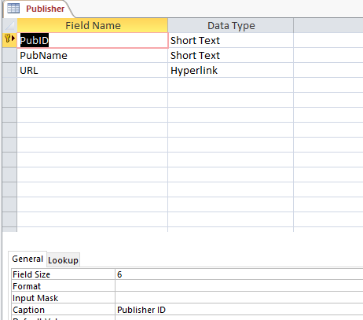
Datasheet view of publisher table

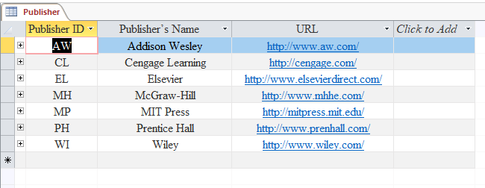

3. Task 02: Importing External Data from Excel
Objective: To import data from an Excel file into a new table.
Steps:
- I imported the Author worksheet from Bookstore.xlsx.
- I selected “Import the source data into a new table in the current database”.
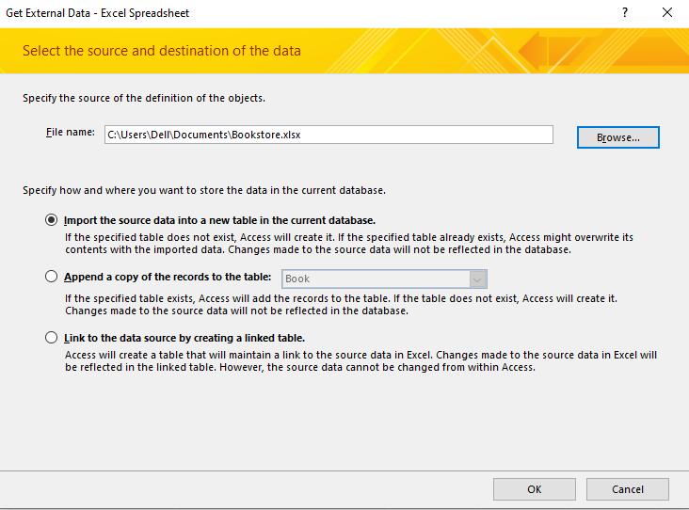
- I ensured “First Row Contains Column Headings” was checked.
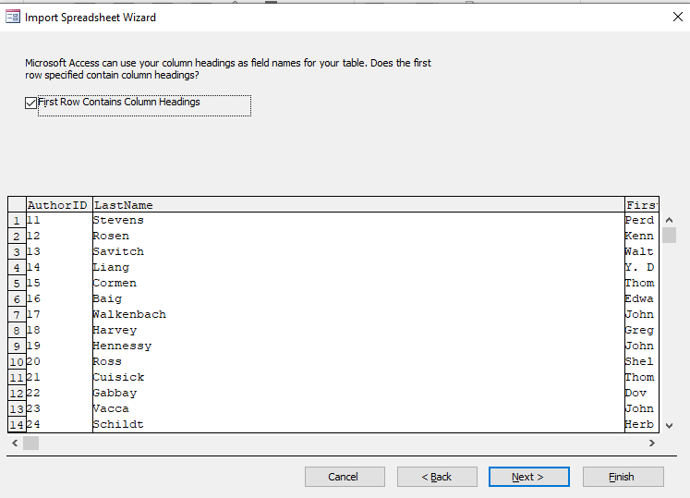
- I set AuthorID to Long Integer, Indexed = Yes (No Duplicates).
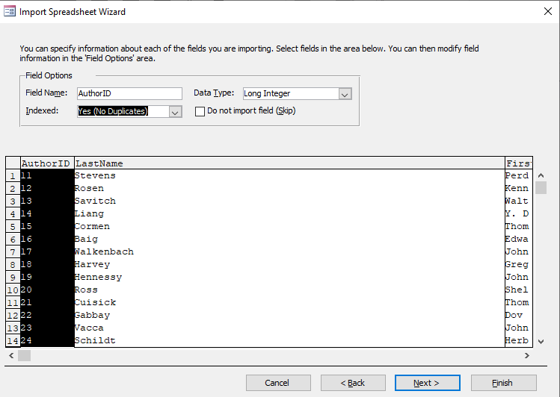
- I made AuthorID the Primary Key and saved the table as Author.
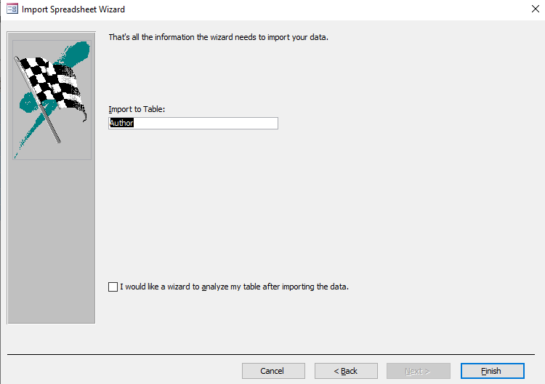

4. Task 03: Creating Relationships between Tables
Objective: To link related tables and enforce referential integrity.
Steps I Followed:
- I opened the Relationships window.
- I created a relationship between AuthorID (Author) and AuthorCode (Book), and enabled Enforce Referential Integrity.
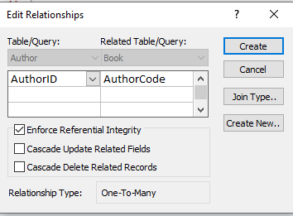
- I created another relationship between PubID (Publisher) and PubID (Book) with referential integrity checked.
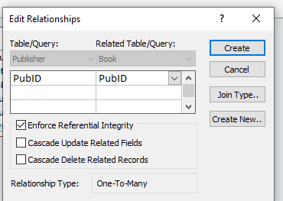

5. Task 04: Creating a Report Using the Report Wizard
Objective: To create a formatted report using fields from multiple tables.
Steps:
- I opened Report Wizard.
- I selected:
  - LastName from Author
  - Title, Price from Book
  - PubName from Publisher
- I grouped by Publisher, sorted by Title (Ascending).
- I chose Stepped Layout, Portrait Orientation.
- I set the report title as Book List.
- I switched to Layout View to adjust column widths.

Report view

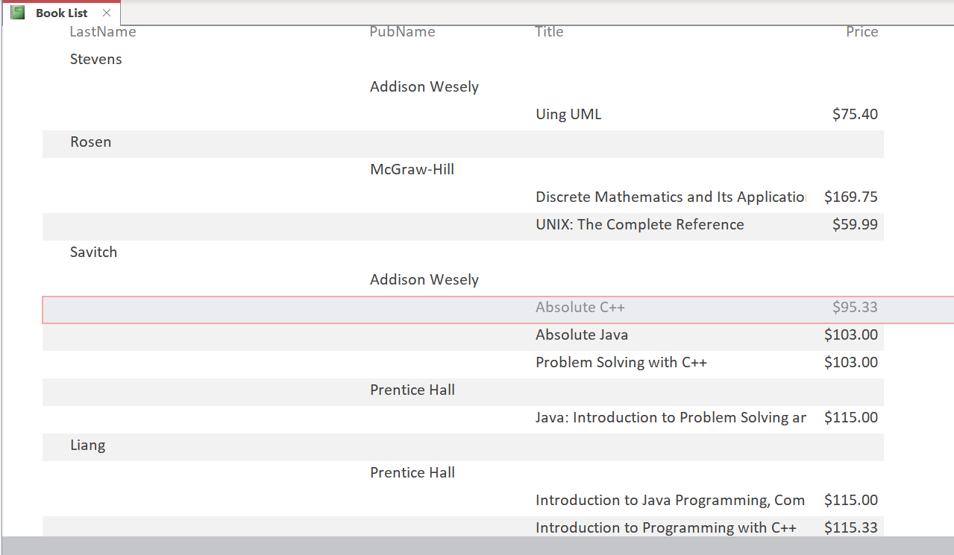
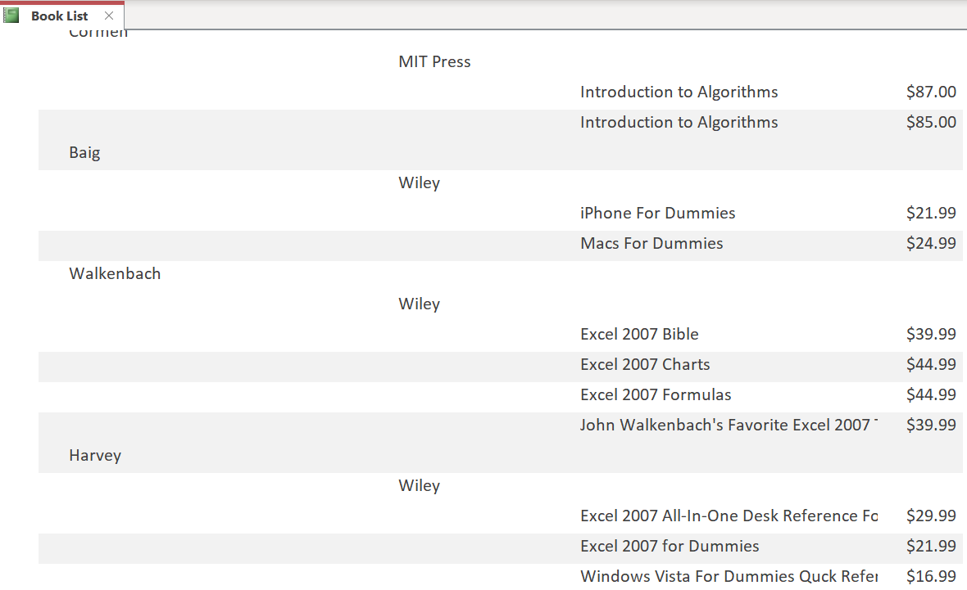

6. Task 05: Creating Queries
Objective: To retrieve data based on specific criteria.

Query 1: Books not yet published
Steps I Followed:
- I opened the Query Design view and added the Author, Book, and Publisher tables.
- I included the following fields:
  - LastName from the Author table.
  - Title and PubDate from the Book table.
  - PubName from the Publisher table.
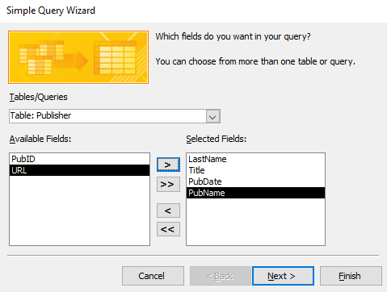
- In the Criteria row under PubDate, I entered:
> #7/31/2007#
- I sorted the PubDate field in Descending order.
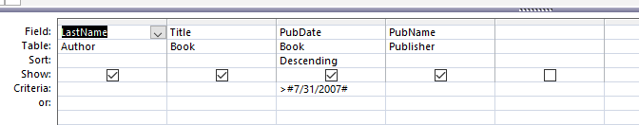
- Finally, I saved the query as Books not yet published.
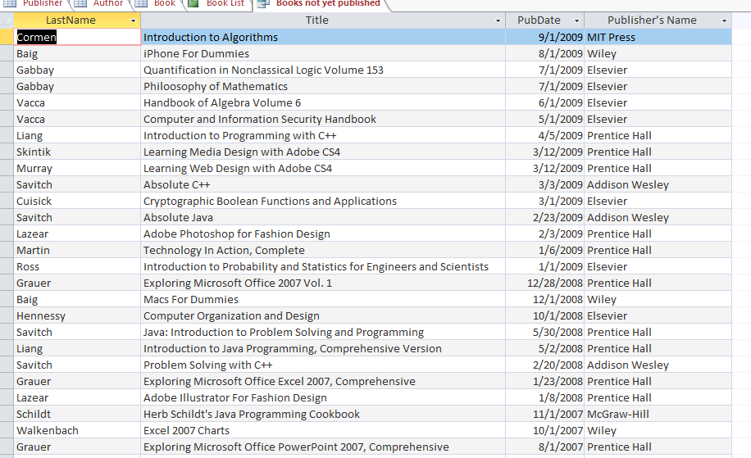

Query 2: First Edition Books
Steps :
- I opened the Query Design and selected the Author, Book, and Publisher tables.
- I included the fields:
  - LastName
  - Title
  - Edition
  - PubName
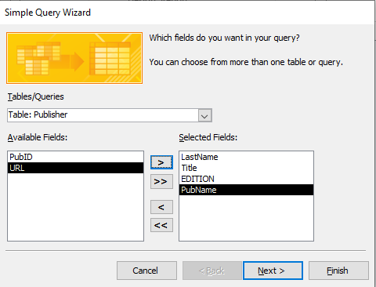
- In the Criteria row under Edition, I typed: Is Null
- I sorted the results by PubName in ascending order.
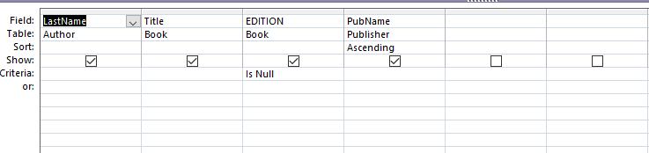
- I saved the query as First Edition Books.
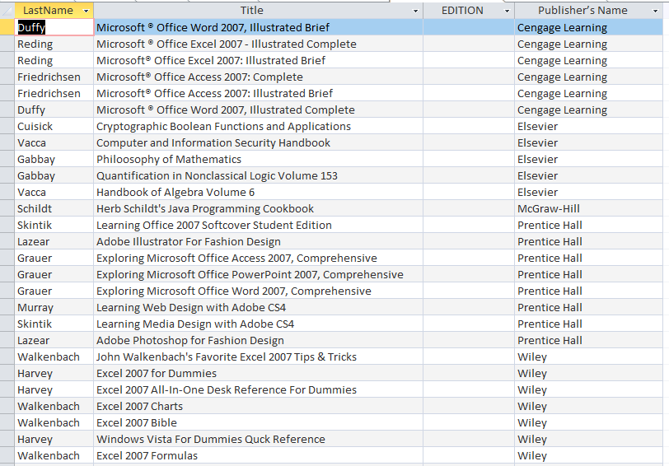

Query 3: Grauer PH Books
Steps :
- I created a new query in Design View.
- I added the Author, Book, and Publisher tables.
- I added the Title field from Book and used the criteria:
  - Price > 100
  - PubName = "Prentice Hall" (PH)
  - LastName = "Grauer"
- I sorted the Title in Descending order.
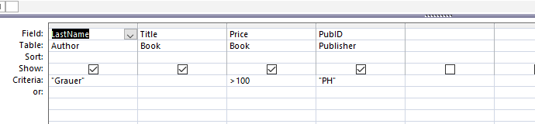
- I saved this query as Grauer PH Books.
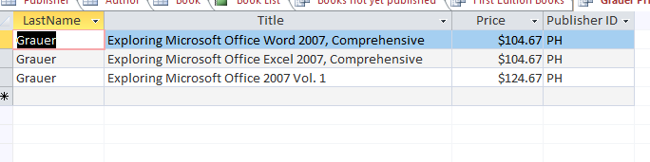

Query 4: New Books
Steps :
- I added the relevant tables into a new query.
- I included the fields:
  - LastName
  - Title
  - PubDate
  - Copyright
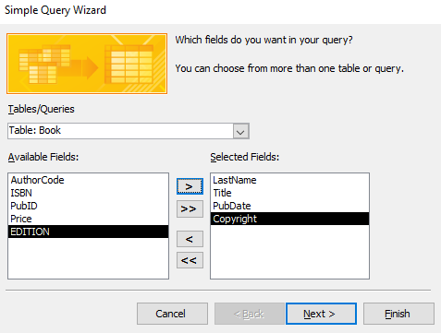
- In the Copyright field, I entered the criteria:
= 2010
- I sorted PubDate in Descending order.
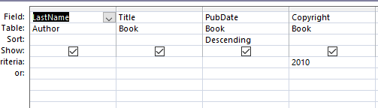
- I saved the query as New Books.
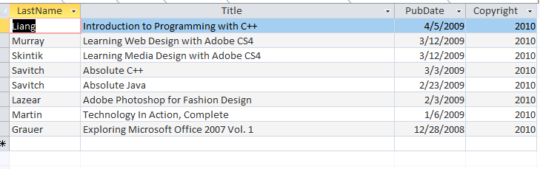

Query 5: Prentice Hall Books

Steps :
- I opened a new query and added the necessary tables.
- I selected fields including at least the Title.
- In the PubName field, I entered:
="Prentice Hall"
- I sorted the results by Title in ascending order.
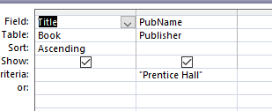

- I saved the query as Prentice Hall Books.
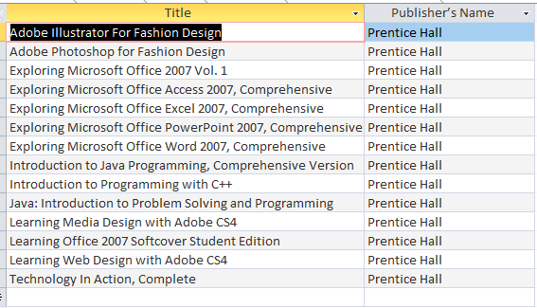

Query 6: Revised Books
Steps :
- I opened Query Design View and added the Book and Publisher tables.
- I selected the fields that include Edition and PubName.
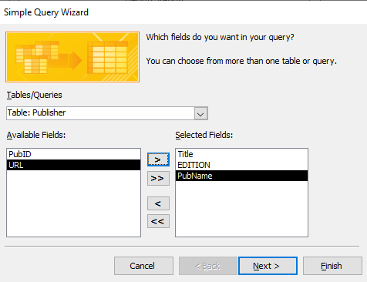
- I used the criteria: Is Not Null under the Edition field.
- I sorted the data by PubName in ascending order.
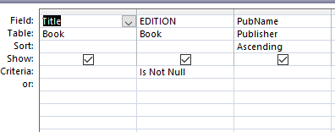
- I saved the query as Revised Books.
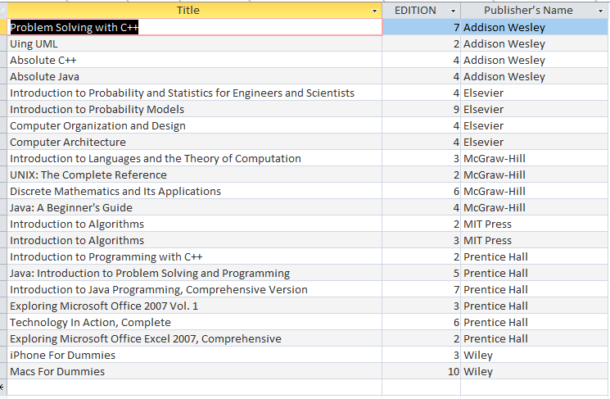

Query 7: Wiley Excel 2007 Books
Steps :
- I opened a new query and added the Book and Publisher tables.
- I selected:
  - Title
  - PubName
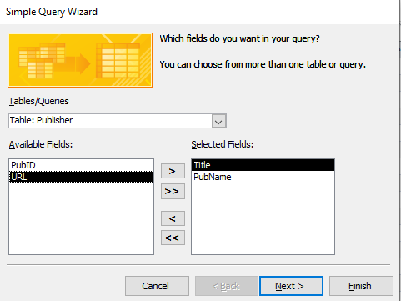
- In the criteria:
  - Title → Like "*Excel 2007*"
  - PubName → ="Wiley"
- I sorted the Title field in ascending order.
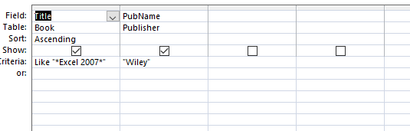
- I saved the query as Wiley Excel 2007 Books.
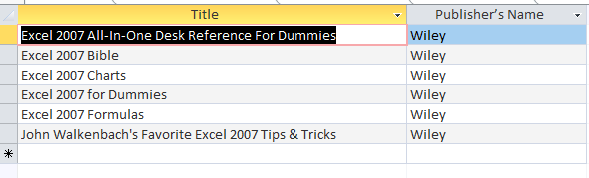
- Reflections and Learnings
In this lab, I acquired knowledge on:

- - Table creation with appropriate data types and properties
- - Data import from external sources like Excel
- - Building relationships for data integrity
- - Report generation using the Report Wizard
- - Writing advanced queries for multi-table data analysis"

8. Conclusion
"By completing the six tasks in this lab, I enhanced my proficiency in Microsoft Access. I developed skills in table design, relationship building, and report generation, which deepened my understanding of relational databases and improved my ability to extract meaningful insights from data.""
__THE END__

